Module 7: Management—Staffing

(Originally compiled by Eric Gonzales and Josh Pilachowski, May, 2008)
(Last updated 8-7-2012)

Outline
- Recap
- Staffing a Single Run
  - Effect of Overtime
  - Effect of Multiple Worker Types
- Staffing Multiple Runs
  - Run-Cutting
  - Covering
- Choosing Worker-Types
- Dealing with Absenteeism
- What is Still Left to be Done
- Appendix: Combining Multiple Worker Types to Cover a Run

Recap
Recall from last lecture the 2-step process we used to cover a schedule:
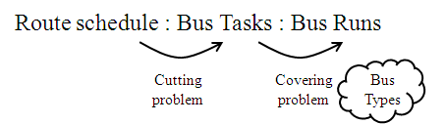
We start with a route schedule and cut it into tasks that can be covered by the buses. Buses, categorized by speed, capacity, etc… are then assigned so that each task is covered. This can be solved as a Vehicle Routing Problem (VRP). The solution consists of all the runs for each bus. If buses were automated vehicles this would be the end of the problem. However, since they are not, we must figure how to cover the bus runs with drivers. To do this we consider the drivers and the constraints they add, using the following sequence:
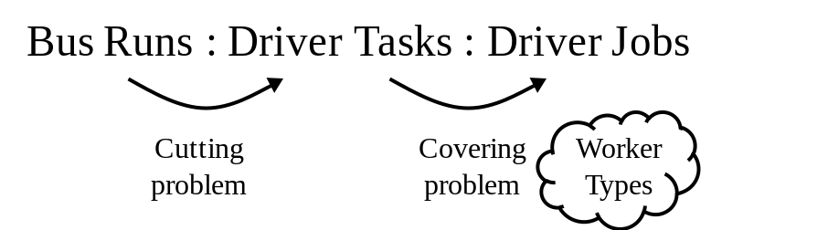
Notice the similarities between the two formulations. The bus runs obtained from the fleet scheduling step are now cut into elementary driver tasks and drivers, categorized by shift length and wage rate, are then assigned to feasible sets of tasks (jobs) so that each task is covered. This is what the focus of this module will be.
Because of the similarities between the schedule covering and staffing problems we can analyze them in a similar way: first by considering each run separately and then by pooling them, allowing drivers to cover multiple runs.

Staffing a single run
The result of the schedule-covering analysis from the last module is a series of runs, r, each with a beginning time, B_{r}, an ending time, E_{r}, and a duration S_{r}. We also take as given the (continuous) work interval for workers of type i, w_{i}. Normally, w_{i} < S_{r} for many runs.

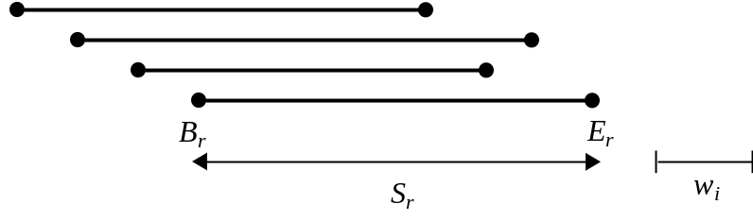

We also assume that we know the wage rate of drivers of type i, as well as the premium added to their wage rate for working overtime. To simplify the formulas we use monetary units so that the wage is 1. In those units, we define the overtime premium as π, and the overtime wage as (1+π).
Consider now the extra cost of wages over the lower bound (LB) obtained by assuming that π = 0 (i.e. that drivers can be hired and paid only when needed. We will examine how this extra cost depends on the types of shifts that are used - assuming that the transit agency has the flexibility to ask workers to start their shifts at any time. First we look at a single run of length S_{r} and set w = 8 hrs and π = ∞ (no overtime offered). Then the extra cost over the LB, $_{w}, is described by the following curve, which is our base case; see figure below.

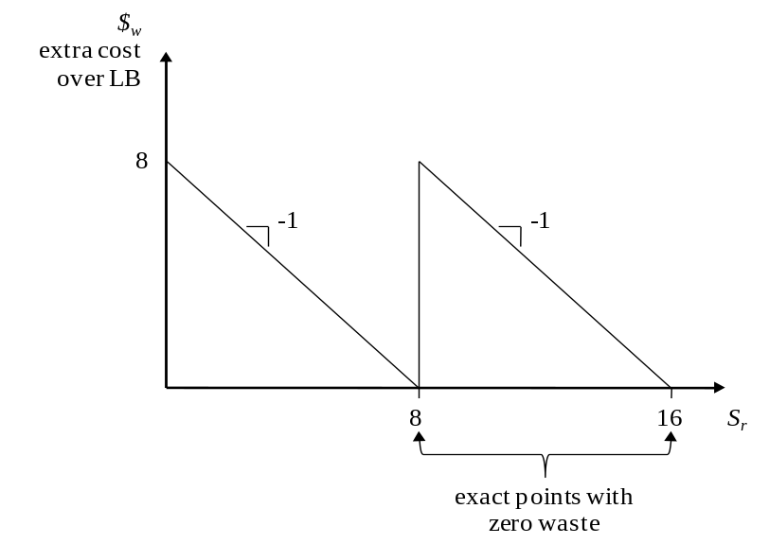
You can see that the largest cost, w, is paid for runs with lengths slightly longer than a multiple of w. Over multiple runs of random duration, the average wasted cost should be about w/2. We waste about one half of a shift per run.

Effect of Overtime
By allowing for overtime (and hiring flexible short-term drivers at the overtime rate), a new extra cost curve with slope π becomes possible, see figure below. The least cost is then the minimum of the two curves. One would use overtime only when the overtime curve is beneath the regular curve (i.e., where the latter is dotted.)
Consideration (see appendix) reveals that the maximum cost is now: 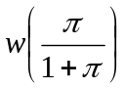. Thus, the excess (wasted) cost per run should be about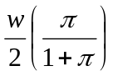 on average. Note how overtime reduces waste.

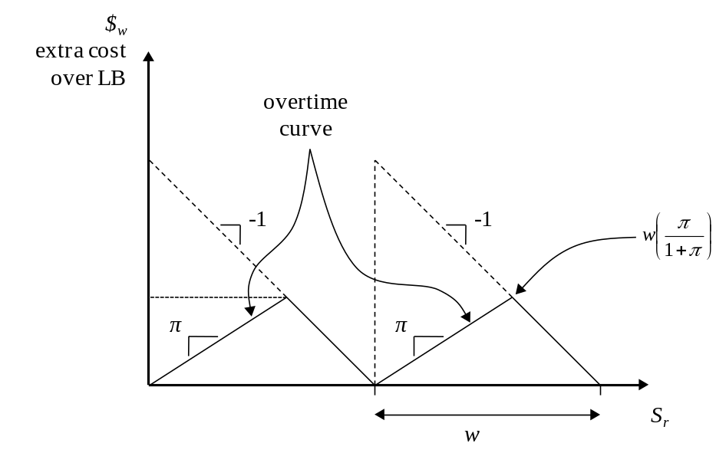

Effect of Multiple Worker Types
If we introduce more worker types to the system we can further reduce our cost. For example, by offering a shorter shift, w₂ = 3 hrs, we can find exact points of zero extra cost for runs with the following lengths: 3, 6 = (3 + 3), 8, 9 = (3 + 3 + 3), 11 = (8 + 3), 12 = (3 x 4), 14 = (8 + 3 + 3), 15 = (3 x 5) … (continuing for all integer values greater than 15). You can see from the figure below that in the range S_{r} ∈ (8, 16), the extra hours of wasted time that can be expected should be about 0.75 without overtime and about 0.375 if overtime with 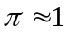 is allowed. (The appendix proves that this solution is indeed the one with the least cost, and also shows how this analysis can be done systematically for more complex problems.)
If we know the cumulative probability distribution, F(x), of all runs, the extra expected cost across all runs can be expressed more precisely as: E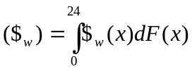 . The take away from this analysis is that by introducing just a few worker types, idle time can be virtually eliminated.

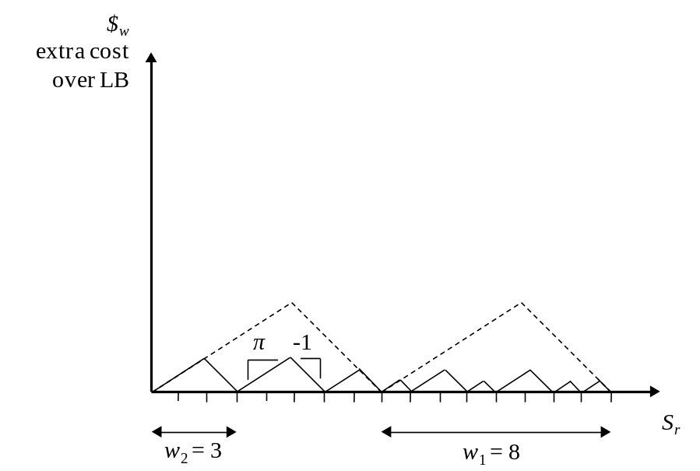

Staffing Multiple Runs
As in the case of the fleet scheduling problem, the situation can still be improved by pooling: considering all runs together and allowing drivers to serve more than one run.
Run-Cutting
To do this, we first cut the runs into elementary tasks, p, that can be covered by different drivers - although each task must be done by the same driver. These tasks should be as short as possible, recognizing the practical constraints that apply to the agency. (Perhaps, for example, drivers can only be switched at certain points on the routes.) The results of the cutting process can be expressed graphically as in the fleet scheduling problem:
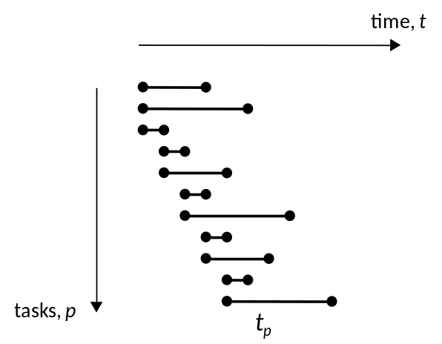
Covering
Data for the problem would include the task duration, t_{p}, the times, t_{pp’}, between the end of tasks p and the beginning of p’, and the real cost of moving a driver from task p to task p’, c_{pp’} (this cost is set to ∞ whenever the move is infeasible; e.g., for all moves where t_{pp’} < 0).
This covering problem can also be formulated as a VRP, albeit a variant with different constraints. The analogy from the previous lecture is continued below:

Vehicle Routing Problem (VRP) | Schedule Covering Problem | Staffing Problem
depot | depot | worker home (or depot)
points i,j | bus tasks k, k’ | driver tasks p, p’
vehicle | bus | Worker
vehicle load | tasks covered by a bus; i.e., the bus run | tasks covered by a worker; i.e., a job
capacity | ∞ | ∞
time for a stop, t_{i} | n/a | t_{p}
time between stops t_{i, j} | n/a | t_{pp’}
distance for a leg, c_{i,j} | p_{kk’} | c_{pp'}
time constraint, T | n/a | w_{i}

For the problem where all workers receive the same wages, we just need to minimize the total idle time and thus can define c_{pp'} as the idle time t_{pp’} in moving the worker from task p to task p’. This cost is set equal to infinity if the move is infeasible. If workers receive different wages, then we should minimize the total cost so that the cost of moving a worker of type i from task p to (feasible) task p’ is the product of his/her wage and (t_{pp’} + t_{p}).
Despite all these complications, the SA method can still be used. We can use the same “state” as in the previous lecture (ordered strings of numbers, p, for each worker) and the same set of perturbations. Only the cost evaluation step would be slightly different. To find an initial solution, we could use the following heuristic:
Step 1. Ignoring flexible workers, rank the rest in order of increasing w_{i}. Then, determine their jobs in sequence, from low to high w_{i}, with the following method:
For each worker,
a. Identify the unassigned task that starts at the earliest time when the number of ongoing unassigned tasks is maximal.
b. Starting with the task identified in step “a”, use the greedy algorithm (looking always for the earliest feasible starting task) to determine the job of the current worker.
Step 2. Determine whether a flexible worker could do more cheaply each job from step 1.

The idea behind this algorithm is that workers with short shifts should cover the demand during the peaks, so as to flatten the residual demand curve when long-shift workers are assigned. The hope is to limit the amount of idle time for both worker classes. The following subsection uses this idea to obtain a rough estimate of idle time.
Simplified estimation of cost
We can use a graphical method in order to obtain a quick estimate for a LB of total cost. To do this we assume that tasks are infinitesimal and that workers can start their shifts at any time and can be reallocated across tasks without a time penalty. This allows us to ignore tasks and instead just focus on the number of runs regardless of where they take place in space. By graphing the number of active runs over time, the problem simply becomes one of covering the area under the graph with “strips” representing a work shift, with a height of one bus and a length, w.

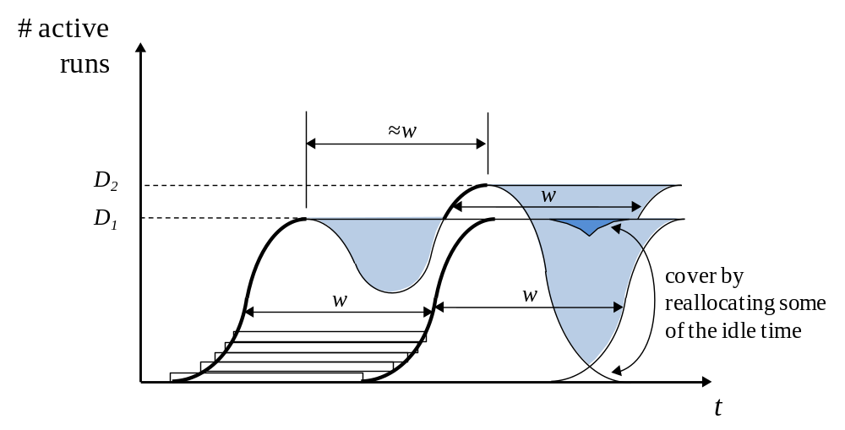

In the above figure, D₁ is the number of active runs during the morning peak, and D₂ is the number of active runs during the afternoon peak. The fewest possible strips have been used to cover the area under the graph. The darker parts of the curve mark the beginning of the strips. The shaded portion of the graph represents the wasted time such that a driver is employed without having a bus to drive. The small portion at the end of the day can be covered by idle workers from the afternoon peak.
Note how the two peaks are separated by the length of a workday, which of course is close to w. This presents a problem, since drivers who start their shifts at the beginning of the peaks must be idle most of their shift. From the picture you can see that there will be (D₁ + D₂)w driver-hours hired.
By allowing some shorter shifts of duration (w/2 = 4) in addition to the regular shifts (w = 8), we could use the short-shift workers to cover the peaks, when the idle time in the previous figure was greatest, and then use the regular shift workers to cover the rest of the demand, which is less peaked. The result could be as in the following figure:

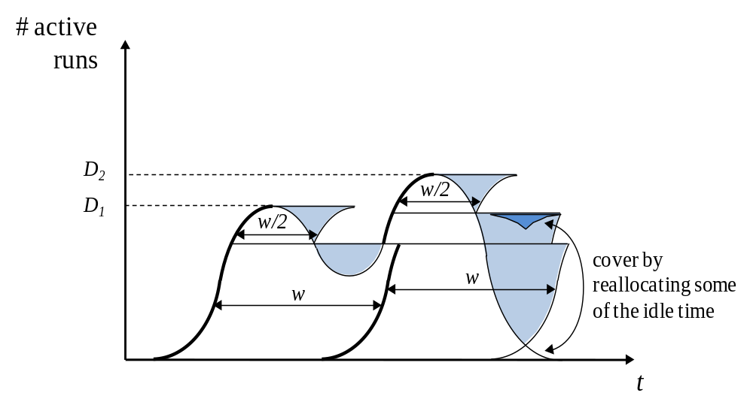

Note that no driver being idle for more than 4 hours even though most of the shifts are of regular length. This is very interesting and useful: a large cost reduction is achieved by hiring just a few 4-hr workers. If we continue this idea by allowing shorter shifts and overtime, the amount of waste can be reduced even more. The homework illustrates this effect.

Choosing Worker Types
We have shown that it is beneficial to have shorter shifts; however there is the question of how to induce workers to choose these shifts. There is the possibility of paying higher wages, but we can possibly provide an incentive other than money. You could offer a shift schedule such that a driver can work 9 hours a day for four days, and then have a 4-hour shift on their fifth day. By partitioning 4-hour shifts for each weekday over all the workers, each day would have a 4-hour shift for every four 9-hour shifts. The normal and 9/4 rotations are shown in the table below:

 | M | T | W | Th | F
rot 1 | 8 | 8 | 8 | 8 | 8
rot 2.1 | 9 | 9 | 9 | 9 | 4
rot 2.2 | 9 | 9 | 9 | 4 | 9
rot 2.3 | 9 | 9 | 4 | 9 | 9
rot 2.4 | 9 | 4 | 9 | 9 | 9
rot 2.5 | 4 | 9 | 9 | 9 | 9

You could then allow drivers to choose their preferred rotation, in order of seniority, with the standard 8-hour shift being the default. This strategy has not been put into practice regarding transit staffing. However similar ideas are used in other fields. Research suggests that the idea could have merit for transit systems.

Dealing with Absenteeism
The above analysis assumes that drivers show up for work reliably. It does not take into account sick leave, vacation time, or absenteeism. Given m, the number of jobs needed, we assume a probability, f, that people will show up to work. We will also assume that absentees are paid. In the best-case scenario, with the same number of absentees every day, we would need to hire n = ⎡m /f ⎤ drivers; e.g., if m = 60 and f = 0.9, we would need 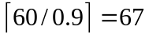drivers.
If we leave n as a decision variable but the number of people who show up to work, N, is random; and if the on-call workers who come in last minute to cover a shift, are paid at a higher rate ($₀>$), then the expected cost would be:
E(cost) = $n + $₀E(m-N)⁺
Here, N is a binomial random variable B(n, f). For large n, (m-N) can be approximated as a normal random variable with mean (m-nf) and variance nf(1-f).
Note: The selection of n presents a tradeoff similar to the well-known “newsboy problem” in which a newsboy maximizes his expected profit by buying just enough newspapers to balance the risks of either running out or having some unsold inventory at the end of the day.
The formula for the expected cost is:
E(cost) = $n + $₀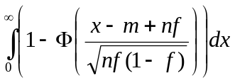
where n is a decision variable, m and f are data, and x is a dummy argument. Here we have used the well known result for the mean of a random variable in terms of its cdf:
E(x) = 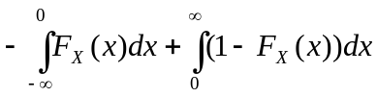; see Figure.
There exists a closed form solution to expected cost integral above in terms of Φ and φ’s, exploiting the fact that 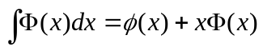. However since the cost can be found numerically, the formula is omitted.

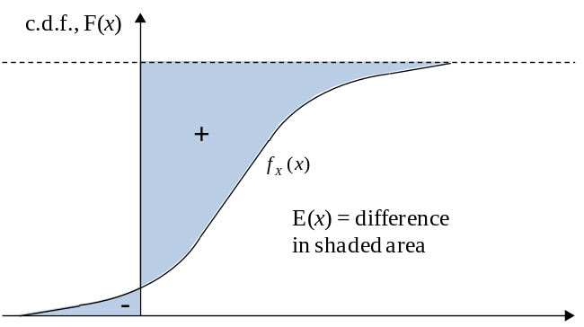
Since for our application the area to the left of the axis in the above figure is small, we will take the mean to be the area to the right of the axis. For the case given at the beginning of this section with m = 60, f = 0.9, and a cost ratio of on-call drivers $/$₀ = 2/3, the optimal solution would be n = 64. This would give an expected cost of 67.1 drivers, which is only marginally higher than our best-case scenario! Of course, worse results would be obtained with smaller pools of drivers. So, having a flexible workforce that can do many tasks is better than having many small pools of specialized workers. The formula we have given quantifies these effects.

What is still Left to be Done
Besides vehicle fleets and personnel, a transit agency also needs to manage other medium- and short-term problems. Some are quite visible to the public and may have to be handled adaptively in real time. We call them operational decisions. They will be examined in the last Modules, albeit not exhaustively. They include:
Real-Time Control of Vehicle Schedules and Response to Service Disruptions (Module 8)
Throughout this course we have dealt mainly with the assumption that buses run on schedule. In reality there are many possible disruptions that can prevent this from happening. These include vehicle breakdowns, delays caused by signals and congestion, and passengers with special needs, all of which can cause buses to divert from schedule. We need to know how best to recover from these disruptions. For example, using GPS and communications technology it is possible to introduce real-time controls which can minimize the effect of these disruptions.
Interaction between Transit and Other Modes (Module 9—in the works)
Because many forms of transit exist within the traffic stream, there are many interactions between transit and other modes. We need to learn how better to manage all modes together. We should learn when and how to segregate different modes on the surface streets so the available street space is better used.
Special events (Module 9—in the works)
Transit can be useful for special events such as the Olympics or emergency evacuations and we need to know how to plan ahead for these.
Appendix A: Combining Worker Types to Cover a Run
This appendix uses the concept of sub-additive functions to develop a systematic procedure for finding the least cost way of covering a run with a multiplicity of worker types. It is assumed that workers can be interchanged anywhere along the run. In our notation, workers of type i = 0 work flexible hours with wage (1+π), and workers of type i = 1, 2… work a shift of duration w_{i} with wage 1. Given is the length of the run, x. We look for the minimum cost F(x) of serving the run with the available workforce, and for the tasks allocated to each worker.
Definition: Subadditive Function. A function f(x) defined for x ≥ 0 is said to be subadditive if f(x₁ + x₂) ≤ f(x₁) + f(x₂), ∀ x₁, x₂.
If f(x) represents the cost of producing a quantity x of something, subadditivity means that the production cost cannot be reduced by dividing the quantity to be produced into parts. Another way of putting it is:
f(x) ≤ f(z) + f(x − z), ∀ z ≤ x.
In this appendix all the arguments of our functions, such as x and z, are understood to be non-negative. Thus, non-negativity constraints such as z ≥ 0 in the above definition are omitted for brevity.
Subadditivity can be checked with the simple geometrical construction of Figure A1. Imagine that the Cartesian axes and the graph of the function are copied on another sheet of paper, and that this copy (dashed lines of Fig. A1) is slid over the original figure, maintaining the origin of the copy over the original curve and without rotating the copy. Then, the function is subadditive if the copied curve never dips below the original at any point. You can convince yourselves with this method that concave-increasing functions are subadditive and that convex functions are not.
What about the cost functions f_{i} shown in Fig. A2 for covering a task of duration x with a single worker type i = 0, 1? One finds by sliding each curve over itself that the slid curves never dip below the original. Therefore, both curves are subadditive. This means that if two (or more) tasks are covered by the same worker type, one can only benefit by combining them into a single task.
How to cover a task with two worker types: Assume now that two worker types i, j are available to cover a task of duration x. The solution of this problem is a cost-minimizing partition of the task into subintervals with a worker type assigned to each interval. However, because the single worker costs are subadditive, we know that if we combine all the intervals corresponding to each worker type into a single one then the total cost can only decline. This is useful because we only have to look for the total amount of time, x_{i}, covered by each worker type.
Thus, the optimum cost F_{ij}(x) with workers i and j is the solution of the following single-variable minimization problem:
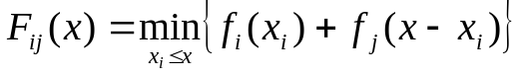 (A.1)
It turns out that this problem can also be solved graphically by the sliding method. This can be seen with the help of Fig. A3, which shows the case with i = 1 and j = 0. (Ignore the double lines for the moment). The value of the argument of the minimum function is shown by the hollow dot, which is obtained by placing the origin of the cutout curve at point (x₁, f₁(x₁)), as shown.
To execute the minimization, slide curve 0 over curve 1 in the interval [0, x] so we explore all possible values of x_{1,} and then find the lowest position of the hollow point at abscissa x. This means that F_{ij}(x) is the ordinate of the lower envelope of all the slid curves evaluated at x. The optimum interval is given by position of the origin of coordinates of the slid curve that formed the envelope at x.
Note that since the point x is arbitrary, the lower envelope itself identifies the values of F_{ij}(x) for all x. Thus the recipe for F_{ij}(x) is rather simple: slide curve j over curve i and take the lower envelope of all the curves that were slid. The result is a graph of F_{ij}(x). This is shown by a double line in the figure. Note that this solution is lower in some places than either f₀ or f₁. This illustrates that combining worker types can save costs.
If we now plot a graph of the function expressing the extra cost over the lower bound obtained after combining workers, which is [F₀₁(x) − x], we obtain the corresponding figure of the text in the section about overtime.
More worker types: We now show how to modify the procedure for more worker types.
Key to this extension is the realization that the function obtained with (A.1) is itself subadditive.
Proof: Consider F_{ij}(y)+F_{ij}(z), and the optimal partition of the two intervals: y’≤ y and z’≤ z. Since these partitions are optimal, we can write: F_{ij}(y) + F_{ij}(z) = f_{i}(y’) + f_{j}(y−y’) + f_{i} (z’) + f_{j}(z−z’). And since the f-functions are subadditive we can combine them and write: f_{i}(y’) + f_{j}(y−y’) + f_{i}(z’) + f_{j}(z−z’) ≥ f_{i}(y’+z’) + f_{j}(z+y−z’−y’). Note that z’+y’ ≤ z+y. Therefore, the value (z’+y’) is a feasible point in the minimization problem:
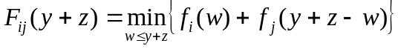
Therefore, this minimum can be no greater than the feasible value: f_{i}(y’+z’) + f_{j}(z+y−z’−y’). It follows that: F_{ij}(y+z) ≤ f_{i}(y’+z’) + f_{j}(z+y−z’−y’) ≤ f_{i}(y’) + f_{j}(y−y’) + f_{i} (z’) + f_{j}(z−z’) = F_{ij}(y) + F_{ij}(z). QED.
To combine three worker types (i, j, k) it suffices to solve:
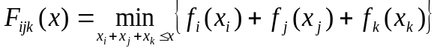.
since the component functions are subadditive. This minimization has two degrees of freedom, so we want to simplify it. Note that the minimization can be performed in two steps as follows:
;
and that the inner minimization is the definition of F_{ij}(x−x_{k}). Thus, we have:
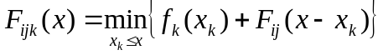. (A.2)
Minimization (A.2) has one degree of freedom. The equation expresses the composition of cost functions F_{ij} and f_{k} with rule (A.1).
This shows that to combine three worker types, we can first combine any two and then combine the result with the third worker type. The procedure can be iterated with as many worker classes as desired. Graphically, at every step we solve a problem as in Fig. A3, using the lower envelope of the prior step as the curve over which one slides the curve of the new worker type.
Example: This method is now applied to solve the problem of the text in which three worker types are combined. A worker type, i = 0, with flexible hours and two worker types with shift durations: w₁ = 8 and w₂ = 3. We start by combining the latter two by sliding curve f₂ over f₁ as shown in Fig. A4. The figure only shows curve f₂ anchored at points O, A and B because these anchors dominate any anchors to their lefts; so the latter are redundant. Thus, the lower envelope of the three shown curves is the solution sought: curve F_{12.}
To find the final solution F₀₁₂(x), we now slide the straight ray with slope (1+π) corresponding to the flexible workers over curve F₁₂ to determine a new lower envelope. This is the final solution. Sliding the ray has the effect of chopping the steps as occurred in Fig. A3. To keep the figure “clean”, the result F₀₁₂(x) is only shown for the first two steps in Fig. A4.
The wasted time over the lower bound achieved with this solution is [F₀₁₂(x)−x]. Note that this function is zero whenever F₀₁₂(x) has a breakpoint, and is bilinear in between zeros as the function of the text. Note from Fig. A4 that the breakpoints of F₀₁₂ (and the zeros of the wasted time) are: (3,6,8) in the first 8hr period; (9,11,12,14,15,16) in the second 8hr period; and (17,18,19,20,21,22,23,24) in the third. This matches what we had conjectured for the function of the text.

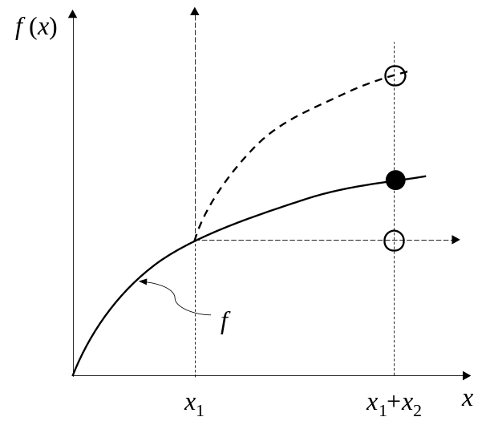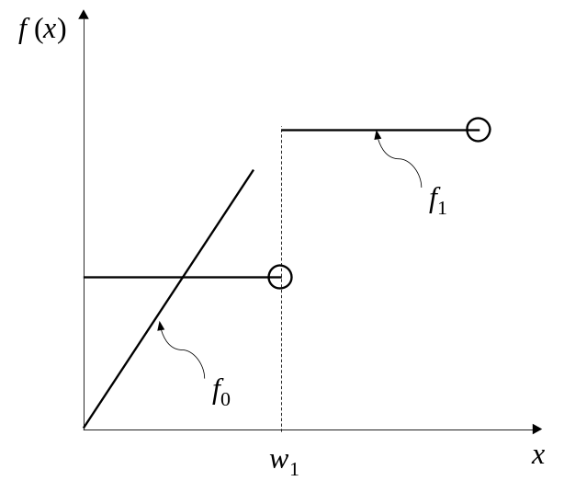
Figure A1 Figure A2

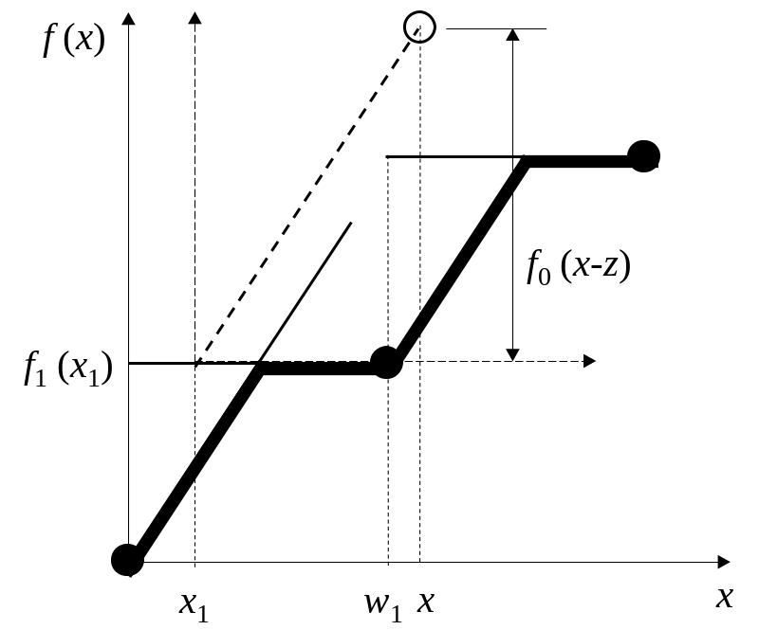
Figure A3

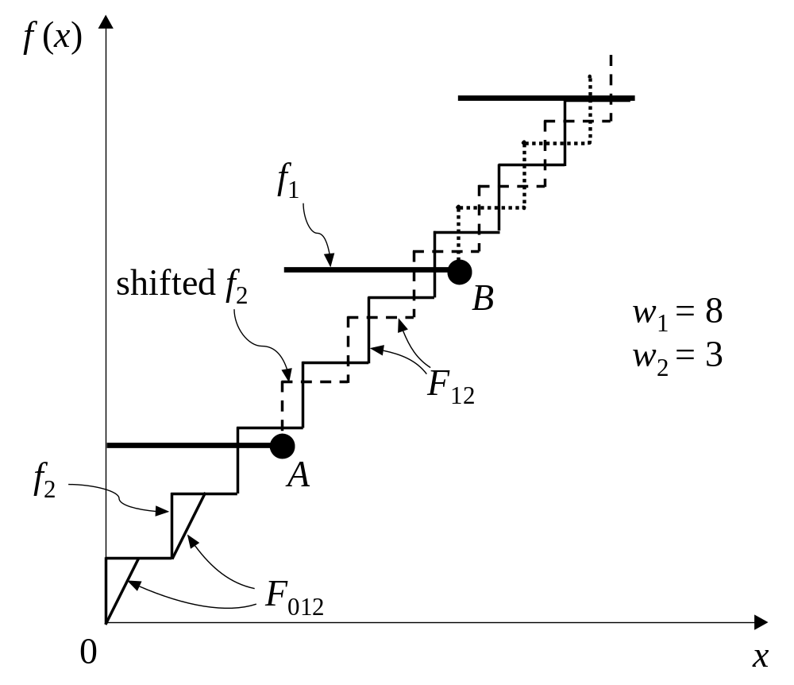
Figure A4

The SA approach can be used even if worker types are characterized by specific beginning and ending time windows for their shifts, and not only by their shift durations. In this case, the initialization procedure would be less effective and should probably be changed.
Coleman, R. M. (1995) “The 24 hr business”, AMACOM, N.Y.
Muñoz, J. C. (2002) “Driver shift design for single-hub transit systems under uncertainty” PhD thesis, Dept. of CEE, U. C. Berkeley, CA.

